Town Hall Meeting
Thursday, November 20, 2025
Our Lady of Sorrows (Vestal), St. Ambrose (Endicott), St. Anthony (Endicott), St. Joseph (Endicott), Our Lady of Good Counsel (Endicott)

Diocesan Profile

Diocese of Syracuse | 1970 | 2020 | % Change | 1970 per priest | 2020 per priest | % Change
Catholics | 397,567 | 196,897 | -50% | 746 | 1,053 | 41%
Baptisms | 10,797 | 1,519 | -86% | 20 | 8 | -60%
Received into Full Communion | 604 | 164 | -73% | 1.1 | 0.9 | -91%
Marriages | 4,417 | 306 | -93% | 8.3 | 1.6 | -100%
Funerals | 4,501 | 3,334 | -26% | 8.4 | 17.8 | 111%
Parishes | 168 | 116 | -31% | 3.2 | 3.2 | 0%
Priests | 533 | 187 | -65%
Catholics per Parish | 2,366 | 1,697 | -28%
Sacramental Engagement per Priest |  |  |  | 38 | 28 | -25%
General Population | 1,207,555 | 1,160,043 | -4%

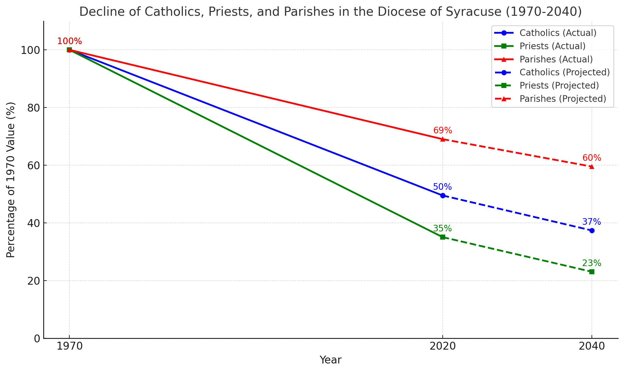

Current Diocesan Data
103 Parishes 130 Churches/Worship Sites
65 Diocesan Priests (Average age: 57) 15 Extern/Religious Order Priests 70 Retired Priests*
75 Deacons (Average age: 68) *13 semi-active

Local Profiles

 | Our Lady of Sorrows | St. Ambrose | St. Anthony | St. Joseph | Our Lady of Good Counsel | Totals
Registered Households | 1258 | 347 | 1,080 | 505 | 882 | 4,072
Seating Capacity | 850 | 450 | 450 | 450 | 700 | 2,900
October 2024 Count | 910 | 276 | 310 | 200 | 358 | 2,054
Baptisms | 22 | 4 | 5 | 21 | 18 | 70
First Communions | 15 | 3 | 11 | 9 | 9 | 47
Confirmations | 27 | 19 | 8 | 10 | 0 (combined with and at OLS) | 64
Marriages | 4 | 0 | 7 | 4 | 3 | 18
Funerals | 37 | 16 | 46 | 25 | 26 | 150

Financial Data
(Losses in parentheses)

 | Our Lady of Sorrows |  |  | St. Ambrose |  |  | St. Anthony |  |  | St. Joseph |  |  | Our Lady of Good Counsel
 | 2024 | 2023 | 2022 | 2024 | 2023 | 2022 | 2024 | 2023 | 2022 | 2024 | 2023 | 2022 | 2024 | 2023 | 2022
Operating  Income | 840,287 | 788,448 | 780,992 | 333,752 | 336,566 | 403,992 | 551,790 | 554,236 | 528,781 | 440,199 | 367,730 | 437,463 | 525,318 | 597,310 | 593,276
Operating  Expenses | 859,626 | 742,272 | 739,549 | 331,869 | 339,545 | 404,626 | 587,004 | 592,206 | 580,539 | 504,903 | 479,016 | 457,914 | 641,095 | 727,156 | 625,068
Net  Operating  Income | (19,339) | 46,175 | 41,443 | 1,883 | (2,979) | (634) | (35,215) | (37,970) | (51,758) | (64,704) | (111,286) | (20,452) | (115,777) | (129,846) | (31,792)
Non-operating  Income | (306,892) | 19,279 | (17,229) | (1,564,328) | 146,434 | (473,073) | 31,392 | 59,610 | 57,119 | (260,162) | 749,456 | 48,080 | (79,200) | 152,605 | (106,383)
Net  Income | (326,231) | 65,454 | 24,214 | (1,562,444) | 143,455 | (473,707) | (3,823) | 21,640 | 5,361 | (324,866) | 638,170 | 27,628 | (194,977) | 22,759 | (138,175)
Cash &  Investments | 455,053 | 747,019 | 694,380 | 1,471,907 | 3,030,887 | 3,088,645 | 218,399 | 319,867 | 278,191 | 1,448,349 | 1,833,152 | 1,228,319 | 547,524 | 1,261,709 | 1,335,972

